SENSES

Anatomy of the eye

Refer to Figure 14.7 in Mader as you examine a human eye model. Label the parts of the eye on the diagram below.

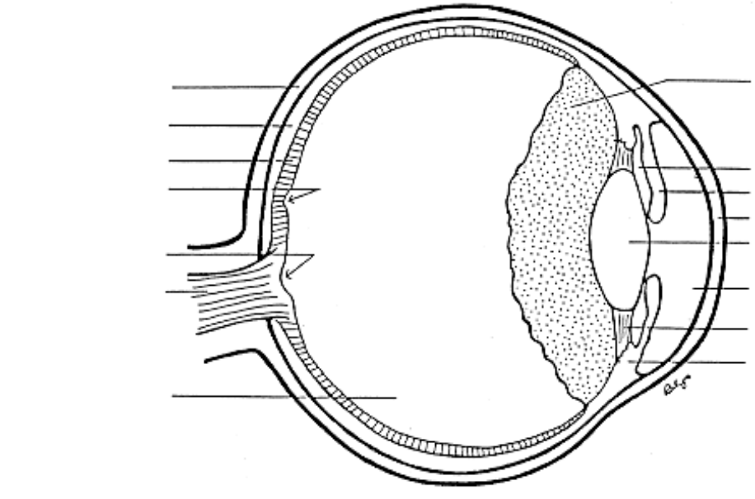

The transparent anterior (front) surface of the eye is the cornea. Light passes from the cornea through the liquid aqueous humor to the lens, the principal light refracting (bending) structure of the eye. The curvature of the lens is adjustable. When one examines a distant object, the light rays from that object need little bending in order to be focused onto the retina, the light sensing posterior surface of the eye. The lens is relatively flat when looking at the distant object because the suspensory ligaments that hold the lens in place and adjust its curvature are taut, and the ciliary muscles that adjust the tension of the suspensory ligaments are relaxed (See Figure 14.8 in your text.). To examine a close object, the lens must accomodate, i.e., curve more in order to bend the light rays at a sharper angle toward the retina. To accomplish this, the ciliary muscles contract, the suspensory ligaments relax, and the lens, because of its natural elasticity, assumes a rounder configuration.

The amount of light reaching the retina is adjusted by the action of the iris, which determines the size of the pupil. In bright light, the iris enlarges to reduce the size of the pupil; in dim light, the iris contracts to enlarge the pupillary opening. If the iris failed to open the pupil adequately in dim light, night vision would be reduced, but there would be no direct danger to the eye. However, failure to close the pupil in bright sunlight could lead to damage to the retina - a visit to an optometrist who administers eyedrops to dilate (open) the pupil for a better view of the interior of the eye is often followed by a painful trip home.

The retina is made up of cells (rods and cones) that respond to light and send nerve impulses to the brain for interpretation via the optic nerve. The rods, distributed throughout most of the retina, can be stimulated by weak light to send signals to the brain. They do not discriminate among colors. The cones, concentrated in the fovea centralis, respond to bright light. There are three types of cones, sensitive to red, green, or blue light. When we see red, it's because the red-sensitive cones are firing impulses, and the blue- and green-sensitive cones are inhibited. The proportions of the different types of cones varies from one individual to another, so different people see colors somewhat differently. In an extreme case, an individual may be totally lacking a particular type of cone, and as a result, may suffer from colorblindness.

Visual acuity, the sharpness or clarity of images, depends on the correct focusing of the incoming light by the lens onto a correctly positioned retina. Additionally, the light must not be scattered or incorrectly refracted by other structures of the eye. Poor visual acuity can therefore be the result of any of a number of defects. Some of these are listed on the next page. (And see Figure 14.12 in your text.)

Vision Defect Cause

Nearsightedness Eyeball abnormally long (retina too far to posterior); lens focusses image in front of retina

Farsightedness Eyeball abnormally short (retina too far to
anterior); lens focusses image behind retina

Astigmatism Several possibilities: irregularly-shaped
cornea, lens, eyeball

"Sunglass effect" Clouding of the lens, vitreous humor of the
of aging posterior chamber leading to light scattering
and/or absorption

Presbyopia (need for Inability of lens to accomodate or "round up"
reading glasses) for close vision due to loss of elasticity

Other structures of the eye to identify include the choroid coat below the retina and the tough sclera. The choroid absorbs light that passes through the retina, preventing backscatter that would degrade visual acuity. The sclera protects the eye and provides a site for the attachment of the muscles which move the eye.

Vision tests

1. Acuity: The Snellen eye chart is the classic means for the determination of visual acuity. The method is simple. The subject stands 20 feet from the chart, covers one eye, then reads the smallest letters possible. A partner should check the accuracy of the reading. If the only line read is the top line (E), then, according to the numerical scale next to that line, the visual acuity is 20/200. The subject reads at 20 feet what normally can be read from 200 feet. The visual acuity is obviously poor. 20/20 vision is the norm; from 20 feet the subject reads what a normal individual should be able to read from 20 feet. What does 20/15 indicate?

Test both eyes by the Snellen method. For those with glasses, check with and/or without your glasses. For those with contact lenses, leave them in - you can check whether your prescription might need change.

Left : 20 /____ Right : 20 /____
2. Near point: The near point is the closest distance at which one can focus. It is a measure of lens accomodation, the ability of the lens to snap back to a curved configuration when the suspensory ligaments relax. With age, the elasticity of the lens decreases; while a 20-year old might have a near point of 8 centimeters, a 50-year old is more likely to have a near point of 50 cm.

Check the near point of each eye. Cover one eye. Hold this page about 2 feet from your face and look at this X. Move the paper closer, trying to keep the X in focus. When it becomes blurred, move the page back to where the X is clear. Have your partner measure the distance from your eye to the page. Repeat with the other eye.

Left __________ cm Right __________ cm

3. Blind spot: At the point where the optic nerve exits the eye, there is a deficiency of light-sensitive retinal cells. Thus each eye has a blind spot. To demonstrate this spot in your R eye, close the left eye and hold this page about 20 inches from your face. Look at the X below while moving the page closer to you. The circle at the right will be seen at first, but at some point it vanishes, to re-appear later as the page gets closer to your face. You can demonstrate the blind spot in the L eye by performing the same test with the page upside-down. Why do we normally fail to notice the blind spot?

X O

4. Astigmatism: When the curvature of the cornea or lens is irregular, the image is distorted, with some areas in focus and others out of focus. This condition, astigmatism, can be revealed by examining a chart of the type shown below. The subject stands twenty feet from the wall chart. All of the "spokes" of the chart are equidistant from the eye, so they should all be in focus. Covering one eye, the subject determines whether any of the spokes "stand out" more clearly than the others. If so, astigmatism is demonstrated; the prominent spokes are in sharper focus.
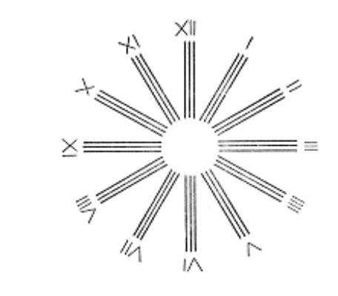

5. Colorblindness: Your instructor will show a series of Kodachrome slides designed to test your color vision. Each slide will consist of an array of colored dots arranged into two numbers. Below, you are to write down the number that you can read most easily. (In case of a tie, write down both numbers) Work quickly- each slide will be shown for only a few seconds. At the end, your instructor will describe how to score your responses to evaluate your color vision. Don't be alarmed if you turn out to be colorblind. About 9% of males and 1% of females are red-green colorblind; the disparity between the sexes in color vision will be explained in the genetics section of the course.

Slide# Response Slide# Response

1 __________ 6 __________

2 __________ 7 __________

3 __________ 8 __________

4 __________ 9 __________

5 __________ 10 __________
Anatomy of the ear

The anatomy and physiology of the ear is explained in the videotape "The Ear as a Sensory Organ", which will be shown during this lab session.

Label the diagram on the next page as you examine a human ear model. Refer to Figure 14.13 in the Mader text.

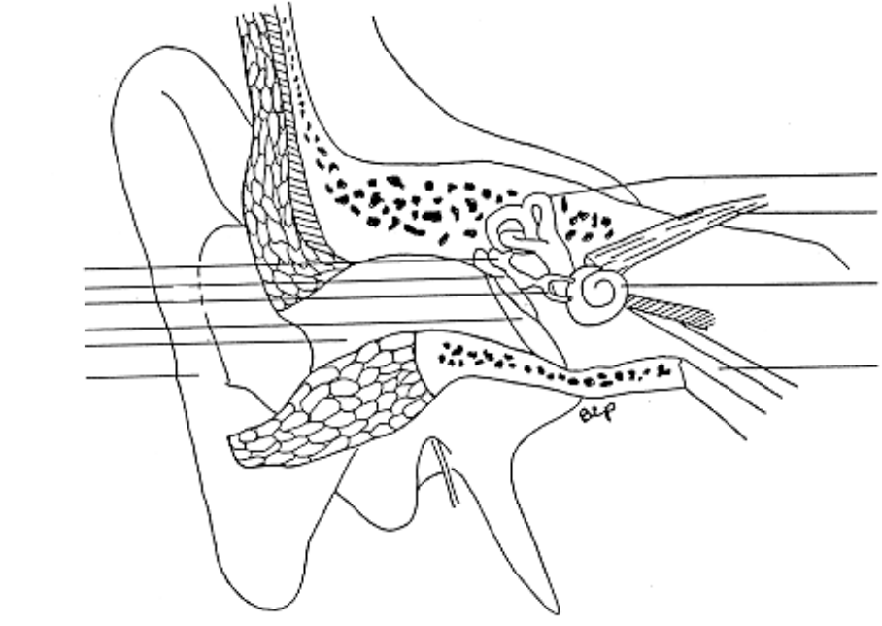

The auditory canal leads into the head from the outer ear and ends at the delicate tympanic membrane or eardrum. The middle ear extends from the inner surface of the tympanic membrane to the inner ear and contains fluid and three bones, the ossicular chain, consisting of the malleus (hammer), incus (anvil), and stapes (stirrup), which serve to amplify vibrations (sound) picked up by the tympanic membrane. The vibrating fluid and the stapes pass the amplified vibrations to the oval window on the inner wall of the middle ear. Also associated with the middle ear is the Eustacian tube which serves to equilibrate air pressure between the middle ear and the atmosphere; it connects to the nasopharynx.
The inner ear begins at the oval window. When the oval window is set in motion by vibrations in the middle ear, the fluids in the cochlea move. Sensory hair cells in the cochlea respond to the motion by sending nerve impulses to the brain via the 8th cranial nerve. Specific hair cells respond to specific sound frequencies, i.e., selected hair cells fire when you hear middle C, while other cells fire only in response to D. The loudness or intensity of the sound is communicated to the brain by the rapidity of the nerve impulses. Loud sounds lead to rapid firing, soft sounds to slow firing of the specific hair cells. Which cells fire and how often they fire is the information the brain interprets as sound. The inner ear also contains the semicircular canals arranged in three perpendicular planes. These structures are involved with sensing body motion; their arrangement permits the detection of motion in all three dimensions.

Exercises in hearing

1. High frequency threshold: Sounds in the conversational range are of a pitch of a few hundred cycles per second (Hz). However, we can hear sounds of much lower pitch (e.g., a bass drum) or higher pitch (e.g., a piccolo). The high frequency threshold varies considerably from one individual to another. The young can hear sounds as high as 20,000 Hz, but the aged can often only hear sounds of comparably intensity up to 8,000 Hz or so.
A simple test will allow you to determine your high frequency threshold for a soft tone. Run the computer program "THRESH" as demonstrated by your instructor. When you first hear the tone, press the F9 key. Your upper threshold will be displayed on the monitor.

2. Auditory fatigue: A tuning fork vibrates at a specific frequency, so when you listen to a tuning fork, only a small group of cells is stimulated to send nerve impulses to the brain. If you listen to the tuning fork for very long, the same cells must continuously respond, and eventually this leads to fatigue. The sound can no longer be heard. To prove this is true, try the following exercise. Strike a tuning fork and place it near one ear until the sound becomes faint. Quickly move the tuning fork to the other ear. What's the result? Explain.
High frequency threshold = ____________ Hz

Do you think you might obtain a different result if the computer's speaker played softer? louder?

3. Bone conduction: Because the cochlea is embedded in bone, vibrations transmitted through the skull can set the cochlear fluids in motion and elicit the sensation of sound. Try the following. Plug your ears, then have a partner strike a tuning fork and place the end of the handle against the top of your head. Do you hear the sound? Now have your partner place the tuning fork against the side of your head near the temple. Do you hear the sound? Does it seem louder on the touched side? Why/why not?

4. Auditory localization: The sense of audition includes the ability to localize the direction from which sound waves emanate. This ability, called stereophony, is really a property of the auditory cortex in the brain. Certain nerve tracts connected to the acoustic nerve cross over within the brain to the opposite hemisheres; hence the brain is able to compare the loudness and quality differences of sounds arriving at both ears simultaneously. To demonstrate auditory localization, work with a partner. Close your eyes. Your partner should snap his/her fingers near the top, front, sides, and back of your head. Can you tell where the sound is coming from each time? Now repeat, except this time plug one ear. Can you determine the source of the sound with the same degree of accuracy?

Microscopic Anatomy

Look at slides of the retina and cochlea. Make sketches below.

Retina: Compare with Figure 14.10 in the text. Can you identify the pigmented layer, the layer of photoreceptors (rods and cones), and the bipolar and ganglion cells?

Cochlea: Compare with Figure 14.14. Can you identify the hair cells and the basilar and tectorial membranes?

Internet Resources

The American College of Ophthalmology provides public information about the eye and its disorders at http://www.medem.com/MedLB/sub_detaillb.cfm?parent_id=30&act=disp.cfm

The National Institutes of Health provides information on hearing, communication disorders and other senses at http://www.nidcd.nih.gov/.

